**Week-1**

1. C++ program to check whether the given number is Armstrong or not
2. To check whether the given number is prime or not
3. C++ program to print the Fibonacci series until the given term

**Week-2**

1. Create a class person with two member functions getData and putData to take the values from the user and display the entered value to the user respectively. The person should have three data members age,salary and name

(i)without constructors

(ii)with default constructors

(iii)with parameterized constructors

(iv)with default, parameterized constructors

1. Addition, cube, subtraction, multiplication using inline functions

**Week-3**

1. Create a test class which gets instantiated by the constructor and displays the values with the help of a friend function. The name of the friend function should be display()
2. Create two test classes test1,test2 which will be instantiated by the constructors .Write a friend function for both the classes which access both the private members and return the absolute difference of both the functions in the main function,we have to display the absolute value.
3. To write a C++ program, to create a class STUDENT with the following specifications:

Data Members: name, roll_number

Member functions: read(), display()

Use the above specifications to read and print the information of 5 students by creating 5 different objects.

1. C++ program to create a class Book with the fields bookno, bookname, price, name of the author. Create methods to read the book information, print the details.

(a)use parameterized constructor

(b) display method

**Week-4**

1. Create a class A with the variables x,y. Create a method to set the date to x and y. Create a subclass B with the variable z. create a method to set the data to z. Write a method to display the information.
2. Create a class Q with a variable q and consider default constructor for setting to q. Create a subclass R with a variable r and consider default constructor for setting to r. Create a subclass to R as S with a variable s and consider a default constructor for setting for s. Create a display function in each of the classes. Create a main method to call the functions
3. Create a class person with the filed firstname, lastname. Use parameterized method to set the values to the variables at runtime. Create sub class Employee with the variable eno, edept, esal. Create parameterized method for setting the data and default method for display the information.
4. Modify the above program by creating a subclass of Employee called Department with the variables dno, dname, experience. Set parameterized method for setting the data and display all the information
5. Create a class named Employee with the following details

Data members:

1. name (b) address (c) age (d) gender

Methods :

(a ) Display () to show the employee details

Create another class FullTimeEmployee that inherits the Employee class :

Data members :

1. Salary Designation

Method :

1. Display () to show the salary and designation along with other employee details.

Create another class PartTimeEmployee that inherits the Employee class :

Data members :

1. Workinghours rateperhour

Methods :

1. caluculatepay() to caluculate the amount payable
2. display() to show the amount payable along with the employee details.

Create objects of these classes and call their methods .use appropriate constructors.

1. Create a class Employer with company_name and city. Create a parameterised method companyDetails(String, String) to set the values to the two variables.  Create a showCompanyDetails() method to display the company information.

Create a subclass Employee with eno,ename,esal. Create a parameterized constructor to set the values to these variables. create a showEmployee() to display the information.

Create a main method to test the classes

1. Create a base class called person

with SSN  and name as data types with getdata and display as member functions. Derive a  new class called student with rollno, branch,mark1,mark2,mark3 as datamembers and getdata and display  as member functions and finally derive a new  class called grade from student class in that calculate the average for marks and display the  grade for the  student

            a. A grade >=90%

            b. B grade>=80%

            c. C grade>=70%

d. Less than 70% fail.

8. Create a class Person with the fileds first name and last name. Set the data and print it. Create two subclasses employee and staff with the variables and methods:

Employee:

Variables: eno, esal, designation

Methods: setEmployee(int, double, String) and displayEmployee()

Staff:

Variable: sno,experience

Methods:setStaff(int,int) and displayStaff()

Create a class to access the information of all

**Week-5**

1. Program for comparing two objects using functions.

2. Program for comparing two objects using operator overloading.

3. Program for addition, subtraction, multiplication and division of two objects using operator overloading and select which operation should be done using menu driven program.

**Week-6**

1. We have discussed stack operations called push () and pop () in the class. Also illustrated with examples. Design and implement menu driven C program with 4 operations. (1) Add element to stack (2) Delete element from stack (3) Traverse elements and (4) Exit. Write all possible examples supported by relevant test cases.

2. Design and implement C program to check a string is palindrome or not using a stack. A **stack** is LAST IN FIRST OUT (LIFO) data structure. The element which is inserted last, is accessed first. Insertion and deletion of elements happens only at top of the **Stack**. The sequence of exit of elements from a stack is reverse of the sequence of their entry in stack.

Sequence of Entry.  
A --> B --> C -- > D --> E  
Sequence of Exit.  
E --> D --> C --> B --> A

3. You have an empty sequence, and you will be given queries. Each query is one of these three types:

1 x -Push the element x into the stack.

2 -Delete the element present at the top of the stack.

3 -Print the maximum element in the stack.

Function Description

Complete the *getMax* function in the editor below.

*getMax* has the following parameters:   
- *string operations[n]:* operations as strings

**Returns**   
- *int[]:* the answers to each type 3 query

4. C++ program on virtual base class function(diamond problem)

**Week 7: Implement programs on Inheritance1**

1. Write a c++ program to demonstrate how constructors are invoked in Multilevel inheritance.
2. Write a c++ program to demonstrate how constructors are invoked in Multiple inheritance.
3. Write a c++ program to demonstrate how constructors are invoked in Hierarchical inheritance.
4. Create a class named person with the variables name, address, age, gender and a method display() to show the employee details. Derive a new class employee from that deptid and designation and display the complete details
5. Create a class person with the filed firstname, lastname. Use parameterized constructor to set the values to the variables at runtime. Create sub classes Employee and Manager with the variables: Employee:eno, edept,esal , Manager: designation, msal. Create necessary methods in both the classes. Preferably parameterized for setting the data and default method for display the information. Create a subclass of Employee called Department with the variables dno, dname, experience. Set parameterized method for setting the data and display all the information.

**Week 8: Implement programs on InheritanceII**

1. Create a base class called **person**  with **SSN and name** as data types with **getdata and display** as member functions derive a new class called **student** with **rollno, branch,mark1,mark2,mark3** as datamembers and **getdata and display** as member functions and finally derive a new class called grade from student class in that calculate the average for marks and display the grade for the student
   1. A grade >=90%
   2. B grade>=80%
   3. C grade>=70%
   4. Less than 70% fail.
2. Write a c++ program for the bank which provides different interest rates for different time periods for the costumers . If the time limit is <2 years the interest is 5% per annum. If the time limit is between 2 and 4 years the interest rate is 8% per annum. If the time limit is>4 years the interest rate is 10%per annum. Identify the inheritance and also use method over riding for display method and a parameterized constructor
3. .Display the total number credits gained by the student and identify the inheritance.

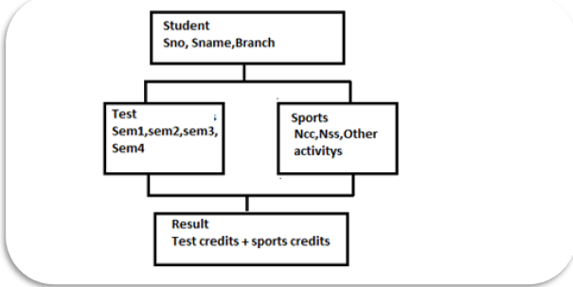

**Week 9: Abstract class**

1. Create a Abstract class called shaped use this class to store two double data type values that could be used to compute the area of figures. Drive two specific class called triangle and rectangle from the base class shape.

Add a member function get data to the base class to initialize base class data members and another function displaying area.

Make display area as a abstract function and redefine this function in the derived class.

1. Use Abstract class to perform payroll calculation based on the type of the employee. We can use base class as employee. The derived class for the employee are boss who gets fixed salary per month, weekly based workers, pieces wish workers who get paid by the number of pieces produced and hourly based workers.
2. Use abstract function conversion for conversion of fahrenheit to Celsius, meters to kilometers, hours to seconds.
3. Create a class named employee with the variables name, address,age, gender and a method display() to show the employee details. Create another class FullTimeEmployee that inherits the Employee class with variables salary and designation. Write a method display() to show the salary and designation along with other employee details. Create another class PartTimeEmployee that inherits the Employee class with variables workinghours and ratehour. Create methods calculatePay() to calculate the amount payble. Display() to show the details.Create necessary methods for that.
4. Use Abstract class to perform payroll calculation based on the type of the employee. We can use base class as employee. The derived class for the employee are boss who gets fixed salary per month, weekly based workers, pieces wish workers who get paid by the number of pieces produced and hourly based workers.

**Week 10**

1. Create a template function which accepts either integer or float or double values and return the sum value
2. Write a  c++ program using function template for swapping of two numbers. (int, float)
3. Write a  c++ program using  function template for bubble sort. (int, float)
4. Write a  c++ program using  function template for finding the maximum of  two element (int, float)
5. Write a  c++ program for overloading a function template.
   1. For addition
   2. For multiplicaiton
6. Write a  c++ program using  class template for linear search
7. Write a  c++ program using  class template for Binary search
8. Write a  c++ program using  class template for performing calculator operations.

**Week 11**

1. Write a c++ program to push the elements from back into a vector and sort them in ascending order
2. Write a c++ program to push the elements from front into a vector and sort them in descending order
3. Write a c++ program to perform linear search using vectors.

**Week 12**

1.DATE AND TIME EXTRACT_REGEX

Meeting Schedule

Ana is the personal security of Ram, So Ram gave all the responsibility of scheduling meetings, appointments from externals and handling the company files. So now Ana, every day has to take the list of meetings, that Ram has to attend and schedule according to that.



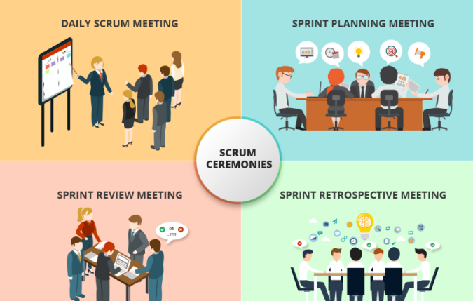

So now she has the list of appointments details, She planned to simplify the details so that she can easily understand. Now she wants to fetch the date and time also the name of the meeting from the given detail.

So let us try to write a program to Extract date and time from the given string. Using metacharacter. If AM or PM is not mentioned, consider it as railway timing or else convert it.

For Ex :

Input: Content Meeting on 12th Jan 2016, at 11:02 PM

Output: Content Meeting - 12th Jan 2016 23:02

Procedure:

1) Extract date from the string.

2) Extract time from the string. Convert it into railway timing, if it's not in railway format.

3) Remove the date and time from the string, using the replace function.

4) Then, remove 'On', 'on' and 'at' from the string.

5) Strip the string, using strip function, to get the context of the meeting.

**Problem Constraints:**

Use regex methods for validating.

Use re and datetime module.

**Input and Output Format:**

Input is a String that indicates meeting details.

The output contains a string contains meeting name, date and time. ( Refer to sample output format).

Note: All text in bold corresponds to the input and the rest corresponds to output.

**Sample Input and Output 1:**

Content Meeting on 12th Jan 2016, at 11:02 PM

Content Meeting - 12th Jan 2016 23:02

Sample Input and Output 2:

11th May 2019 at 05:30 PM Meeting with CEO

Meeting with CEO - 11th May 2019 17:30

Additional Sample TestCases

Sample Input and Output 1 :

Content Meeting on 12th Jan 2016, at 11:02

Content Meeting - 12th Jan 2016 11:02

Sample Input and Output 2 :

11th May 2019 at 05:30 PM Meeting with CEO

Meeting with CEO - 11th May 2019 17:30

Lab task Feb 12 (2)

Experiment - 2

2.It is IPL Season and the first league match of Dhilip’s favorite team, "Chennai Super Kings". The CSK team is playing at the IPL after 2 years and like all Dhoni lovers, Dhilip is also eagerly awaiting to see Dhoni back in action.

After waiting in long queues, Dhilip succeeded in getting the tickets for the big match. On the ticket, there is a letter-code that can be represented as a string of Latin letters.

Dhilip believes that the CSK Team will win the match in case exactly two different letters in the code alternate. Otherwise, he believes that the team might lose. Please see note section for formal definition of alternating code.

You are given a ticket code. Please determine, whether CSK Team will win the match or not based on Dhilip’sconviction. Print "Yes" or "No" corresponding to the situation.

Note:

Two letters x, y where x != y are said to be alternating in a code, if code is of form "xyxyxy..."(case insensitive).

Input Format:

First and only line of the input contains a string S denoting the letter code on the ticket.

Output Format:

Output a single line containing "Yes" (without quotes) based on the conditions given and "No" otherwise.

Refer sample input and output for formatting specifications.

Sample Input1:

ABABAB

Sample Output1:

Yes

Sample Input2:

ABC

Sample Output2:

No

Sample Input3:

XYXYX

Sample Output3:

Yes

3 4. 5. 6 => ques

2a, 2b, 4b, 6b (questions of assignment 2 also in week 12)

7.Write a C++ program to perform various operations on STLList.

8. Write a C++ program to perform various operations on STL Deques.